Tech & Tactics | Wichowski

Policy Memo Talking Points Conversion: Example

EXAMPLE: United Nations Development Programme: Digital Strategy
https://digitalstrategy.undp.org/assets/UNDP-digital-strategy-2019.pdf

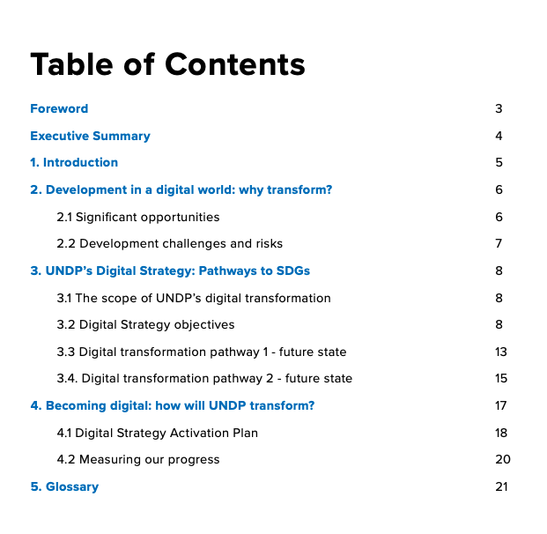

STEP #1: Extract headings and subheadings from Executive Summary

Workstream 1: Establish leadership for the digital transformation
Workstream 2: Enable Information Technology (IT) to deliver the digital transformation
Workstream 3: Empower and inspire the business and increase digital capabilities and capacities
Digital Transformation Pathway 1: looks outward at how we can use digital technologies to improve the way we work, including how we deliver, create, collaborate and advocate.

STEP #2: Starting from the left on the table below, rewrite headings and subheadings in PLAIN ENGLISH (it must pass the Up-Goer-Five Text Editor test!). Then create talking points that will give your speaker substance to share the public.

POLICY LANGUAGE | SIMPLIFIED LANGUAGE | POLICY EXAMPLE | SIMPLIFIED EXAMPLE | TALKING POINT
Establish leadership for the digital transformation | Put people in charge of making computers work better for everyone | ◆ Chief Digital-UNDP Officer  ◆ Digital Champions | One person in charge will be the number one person at UNDP for making computers work better for everyone.  The other person in charge will be many people who want to talk about and show other people why making computers work better for everyone is good. | #1:  - It’s not enough to talk about making changes. We need to put leaders in charge of bringing technology into people’s lives.  - The FIRST leadership position we announce today is the “Chief Digital-UNDP Officer,” who will be in charge of making sure everyone can enjoy the benefits of technology  - The SECOND leadership positions we announce today are the “Digital Champions,” who will spread the word and share their knowledge about how technology can be used to improve lives.

