EXAMPLE: US Department of State Quadrennial Diplomacy and Development Review (QDDR)
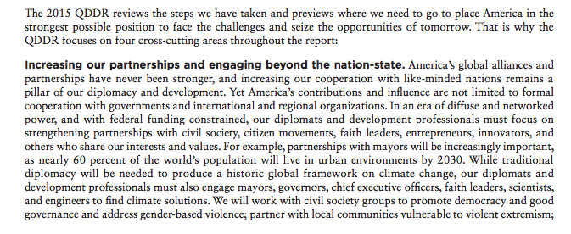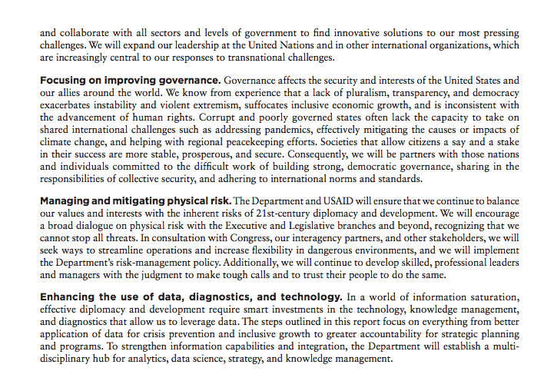

STEP #1: Extract headings and subheadings from Executive Summary

- “Increasing our partnerships and engaging beyond the nation-state”
- “Focusing on improving governance”
- “Managing and mitigating physical risk”
- “Enhancing the use of data, diagnostics, and technology”

STEP #2: Rewrite headings and subheadings in PLAIN ENGLISH (it must pass the Up-Goer-Five Text Editor test!)

POLICY LANGUAGE | SIMPLIFIED LANGUAGE | POLICY EXAMPLE | SIMPLIFIED EXAMPLE | TALKING POINT
“Increasing our partnerships and engaging beyond the nation-state” | Work with other people and groups, and not just those who have the most power over those people and groups | “For example, partnerships with mayors will be increasingly important, as nearly 60 percent of the world’s population will live in urban environments by 2030. While traditional diplomacy will be needed to produce a historic global framework on climate change, our diplomats and development professionals must also engage mayors, governors, chief executive officers, faith leaders, scientists, and engineers to find climate solutions.” | What this means is we will work with people who lead cities. 60 out of every 100 people will live in cities by 2030. We will also still need to work with the big people who lead everyone in a place so that we can work together to stop hurting the living world. But we also need to work with people who lead cities, states, businesses, people who lead groups that all believe in the same thing, people who study how the world works, and people who build things, to find ways to stop hurting the living world. | Point #1:  - We need to work with everyone, not just other national governments  - 60% of people will live in CITIES by 2030. So, we need to work with MAYORS, not just presidents  - BUT, we STILL NEED to work with national governments on BIG ISSUES, like climate change

